The foundational blocks of fiction

1. Characters- Give a vivid physical description of the characters of how they look like. No need to give a lot of detail. Just like JK Rowling give a description of hart potter and of Hagrid for eg

PHYSICAL DESCRIPTION: "He was almost twice as tall as a normal man and at least five times as wide. He looked simply too big to be allowed, and so wild - long tangles of bushy black [hair](http://www.happychild.org.uk/harrypottermagic/book01/items/H.htm#hair) and [beard](http://www.happychild.org.uk/harrypottermagic/book01/items/B.htm#beard) hid most of his [face](http://www.happychild.org.uk/harrypottermagic/book01/items/F.htm#face), he had [hands](http://www.happychild.org.uk/harrypottermagic/book01/items/H.htm#hands) the size of dustbin lids and his [feet](http://www.happychild.org.uk/harrypottermagic/book01/items/F.htm#feet) in their leather [boots](http://www.happychild.org.uk/harrypottermagic/book01/items/B.htm#bootsleather) were like baby dolphins.”  
  
Dont tell too much in the story but show the action…

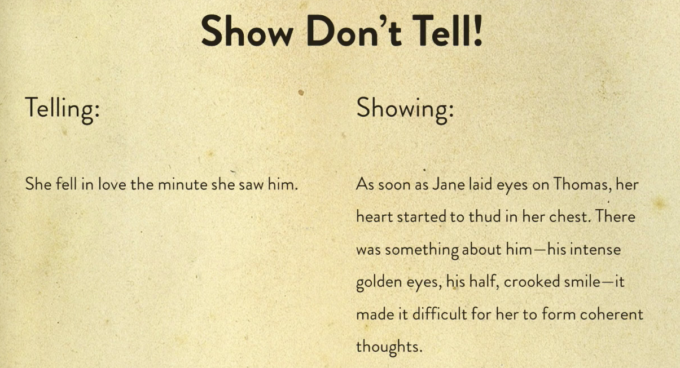

Show don’t tell

Describe how snehil drinks tea… Avoid the mistake to write every thought the character has but describe them only at the crucial moments. In my book I am telling not showing…

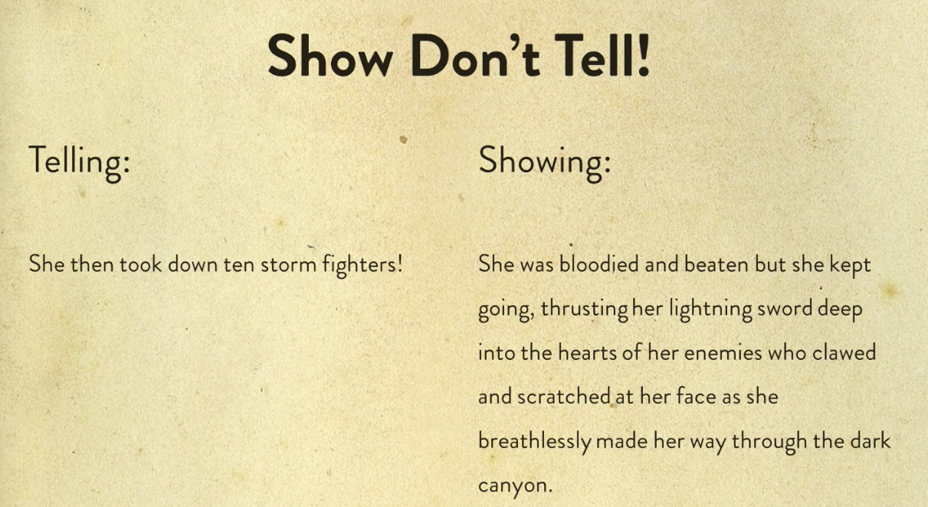

Show don’t tell 2

Video 5.

Character need to have desire and goals. The goals doesn’t not necessarily ned to be great one but they should be moving towards something. A character should have strong motivation and desires.

Video 7 Uniqueness

The main character does not have to have the obvious qualities. They should have a spark in them. Give the characters at least 5 unique qualities and traits. Think about the qualities. And reveal these qualities in your story as surprises.

Video 9 Video 11 Flaws in your characters/Change

Always think about the flaws your characters may have as characters with flaws come out to be more real and relatable. Flawed characters are remembered for long.

Fictional characters go into a change while trying to overcome their flaws.

Remember: Change can be as subtle as a step in the new direction, shift in belief or a willingness to question a rigid view.

Practice:

Write a bad description of a your first grade teacher giving too much of information in 10 minutes.

My first grade teacher’s name was Mis Archana. She was a mid 40s woman with a wrinkled face. She was short in height, not even complete 5 feet. She used to wear Suit salwar daily to the school and her plum body made her look like a football. She had brown eyes that had a look of anger. She had black curly hair and in the hot days of summer her face used to profusely dripping of sweat. Her hands were hard and masculine and her voice was strict and dominating. She used to teach Hindi subject and her demeanour was

2. Dialogue

Dialogue is not a transcribed speech but distilled speech- the filler and inert small talk are edited away. (this is a mistake we have done in the book. Reading the realistic dialogue gets dull. Stick to the point and include only the part of the conversation that are important.

Dont be too fake in the dialogue.-> avoid too much information.

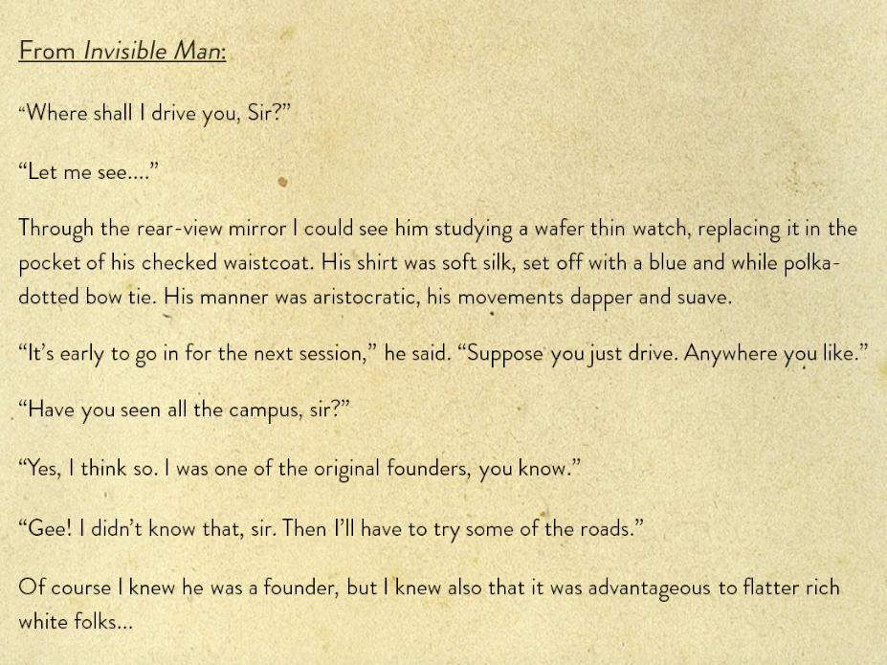

Example of a good dialogue

The author here focuses on the relevant parts of the dialogue. The dialogue should be punctuated with physical descriptions like what are the wearing and how do they look at their watch. The dialogue that is between too realistic and too fake is what is a good mark.

There are two types of dialogues-

Direct and summarised. In our novel we have to use a mix of both…

Summarised dialogue is where the exact words of the speech is not written, instead the meaning is summarised. These are used when long conversations in the book has to be cut short so that it doesn’t feel boring to the reader.

In the direct dialogue the exact words are used in the speech including the quotation marks. These are used to describe the important moments in the story,

A dialogue consist of two people and a situation also known as conversation topic.

**Video 6**

Use tags like (she said furiously), use different adjectives and adverbs.

Instead of saying,”the dog went to the garden, we say-> “The cute, brown dog ran hurriedly into the garden. But don’t over use.

He said, she said are common tags but you can use ,yelled furiously or muffled in a short husky voice.

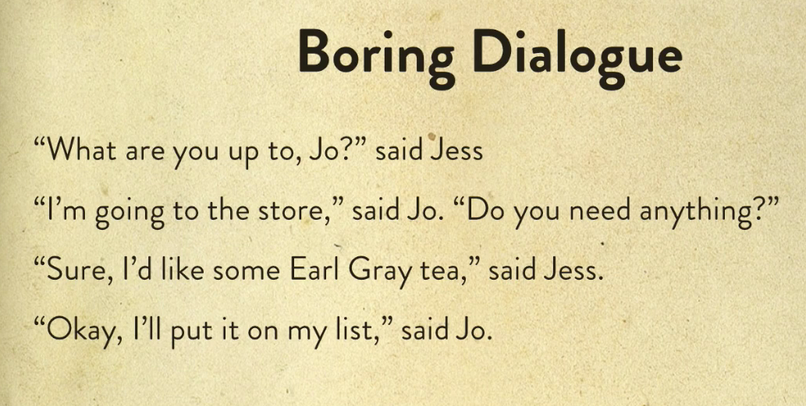

Sample of a boring dialogue

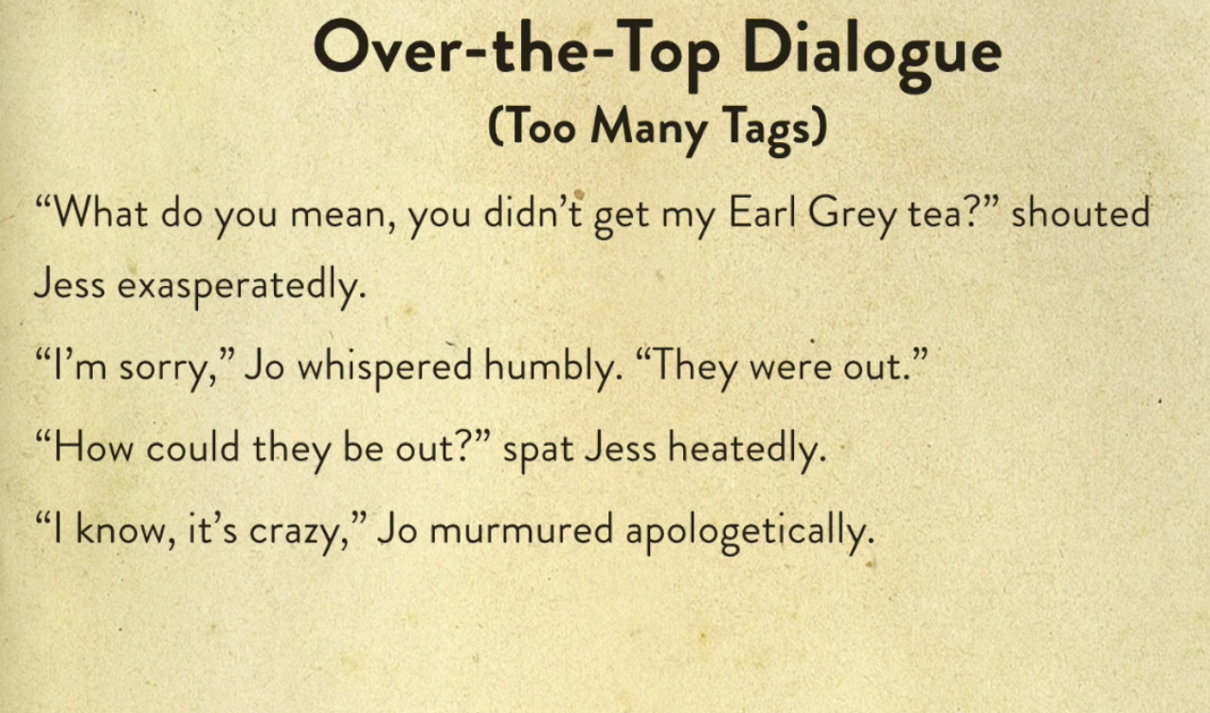

Using too many tags

Sometimes it is fine to use he said and she said. You can also try for a dialogue that can speak for itself.

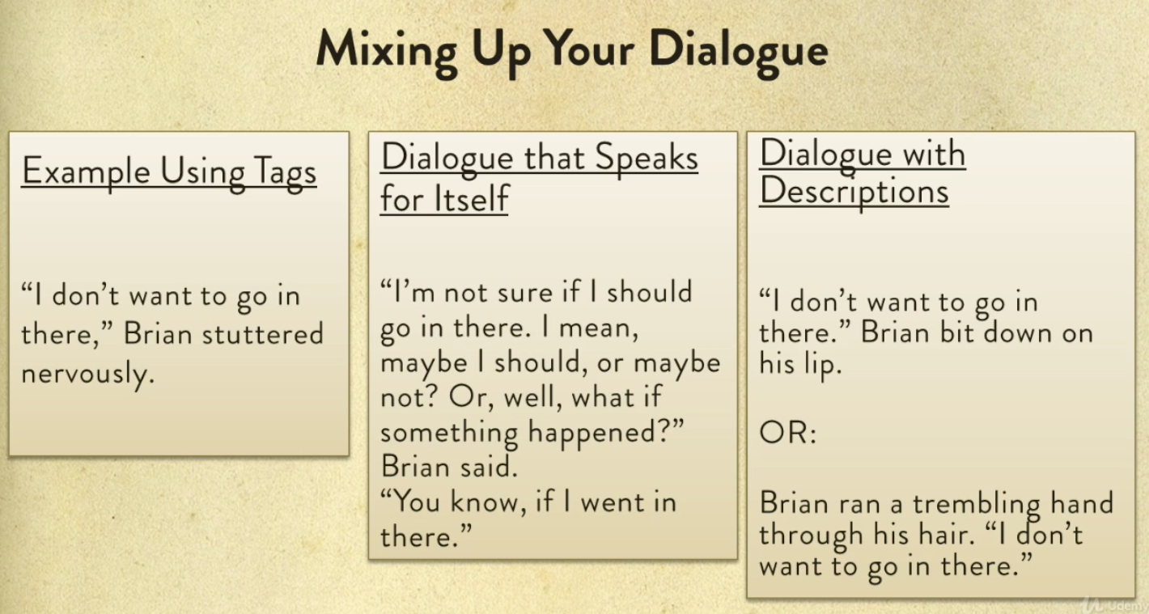

Mixing up dialogue to make it more appealing: Remember to show not tell

Do not overuse, your audience don’t need to know all the movement and facial tick.

**Video 7. Characterising dialogue**

Check out the book on writing fiction by Anne Mazer and Ellen potter.

You can use the writing dialogue by eliminating the he said she said by making the dialogue obvious so that you readers get to know who actually the character is. This is called characterising through dialogue. The dialogue should read like a play.

**Video 9: Subtext**

Write a dialogue in such a way that the character is saying something and meaning something else. This can be a little hard to master at once but can be very engaging. The easier way to use subtext is to first show what the character is thinking in his mind and then compare it with what he/she is actually saying .

Skim the book Annie Hall- a nervous romance by woody Allen.

Look for what’s not being said.

**Video 10: Dialect:**

The way people speak can be tricky to copy. Use it wisely…

3. Point of View(POV)  
  
There are three kinds of point of views.  
-First person-Telling a story using I and me and one of the character is the narrator of the story.   
  
**Benefit:** First person is more personal. Audience will be able to relate more. Also in this type the main character usually tells you the story.  
  
**Disadvantage:** You are stuck to only in the head of one character.   
  
Book to check out for writing in first person- To kill a mockingbird by harper lee, - The Martian, Because of win dixie This type of style is most common these days.  
  
 -Make sure that you stay true to the character’s voice.  
 -Get inside your character’s head to think and speak like they do.  
 -To make it easier start with the character who is like you.  
 -Otherwise, make sure to really think about how your character would see the world  
  
You can be an omniscient third person but that would be challenging. So you can use multiple POV’s i.e telling the story from the points of view of multiple characters. Books to check out for multiple point of views in first person- The help   
  
  
-Second person- There are books that have been written in second person where the narrator is communicating with another character in the story. The style is less common.   
  
-Third person  
 Omniscient-The all knowing character-The narrator is all knowing, all seeing and can skip around in time. The narrator can see inside the heads of lot of characters.   
  
Benefit is that you get to know it all or you get to know a lot.  
  
Challenge is that it can get confusing unless you are doing it well.  
  
Omniscient third person is not used widely in modern days. But it is found in older classical novels. Modern or contemporary novels used limited third person or closed third person.   
  
In Close or limited third person- the narrator can only see in the head of only one character namely the main character. We only see the world through one person’s eyes. We can’t jump into other characters thoughts. Book- The statistical probability of love at first sight by Jennifer E smith  
Writing in limited third person style is fairly easy as you only write the thoughts of your main character. If you want to suggest what another character might be thinking or feeling then you have use their dialogue or physical gestures like how they look.  
  
Video 8) Unreliable narrator- It is a first person narrator who cannot be trusted.

“All first person narrators are somewhat unreliable. Even the most scrupulous character may unconsciously perhaps share the truth or emphasise one fact over other to make them look slightly better…” Valerie Vogrin

Unreliable narrator is works well if the character is good when the character is either drunk or a perpetual liar or with special condition.

4. Narrative Style

**Video 1 Tenses-** Narrative style is all about how a story is told to the reader.

Tenses is a choice between to tell a story in past or present. Most common fiction is told in past. It is also easy compared to the present. Though you can tell a story in present but it has a limitation as the narrator cannot make strategic decision in the story as everything is running in the present as the narrator cannot know more than the reader and it limits the way details are revealed. The benefit of the present tense is that it puts the reader right into the action. If you want to check out a novel written in present tense then you can check out the book wolf hall

**Decision- I am going to tell my story in the past and use the first person POV**

**Video 2 Show and tell-** This is all about when to show and when to tell. You have to mix the two when you are writing the novel.

For eg. **Tell->** Chole was an old dog.

**Show->** Chloe’s Grey Whiskers drooped down , long and matted, each side of her moist black nose

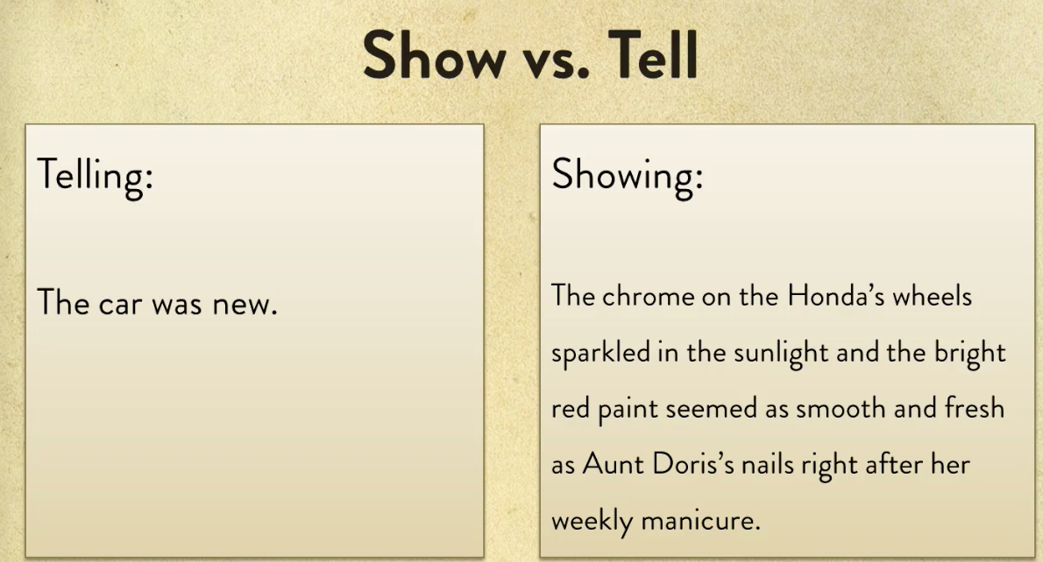

Showing Vs Telling

Telling is summarising and showing is slowing things down, zooming in, and describing details that really help the reader to paint a picture in their mind.

Instead of looking at the story from a great height, showing is all about getting on the ground and see, hear and feel everything closely. The best way to this is details which should be vivid, specific and sensory.

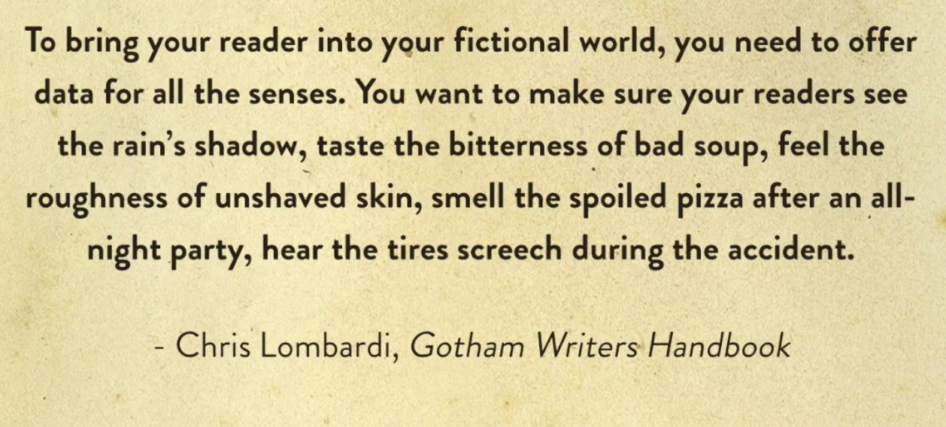

How details should be told

We can not only show the details of places, objects or person but can also show details of events, actions and emotions of the characters.

Don’t go over the top when showing. It is preferable to show and tell as telling can be important to keep the story moving forward.

Showing can be reserved for important moments like when you want to show how the character’s home or how they slay a dragon and actions and events Don’t show how the characters drink a glass of water, brush their teeth, get’s ready for work.

**Video 4 FlashBacks**

Flashbacks can be a great device to use in fiction but they can be tricky to do well. They can be useful to add depth and intrigue into the writing. They can vary in length- from fleeting memories to detours into the past. For flashbacks we have to use the readers imagination. You have to give attention on how to transition from the present moment and the past and vice a versa. Try to avaoid cliche transition phrases like “Charles thought back in time” or “she drifted back into the memory”

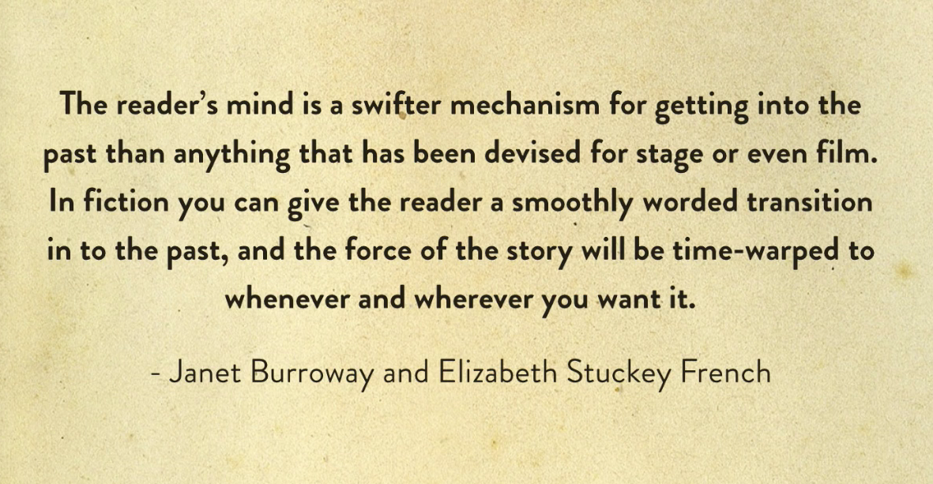

Flashbacks

When the flashback is over it must be clear that you’re coming back into the present. Avoid using flashbacks within flashbacks. Don’t overuse flashbacks as they may confuse the reader. The flashback’s disadvantage is that it disturbs the flow of the story so it is to be used only when necessary, Use dialogue or a brief summary to describe the past eve**nt.**

**Video 9 Diffrent formats:**

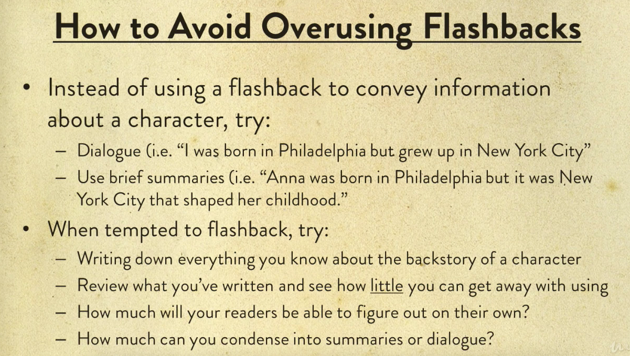

Writing flashbacks effectively

5. Setting

Do not add to much of information

Choose carefully the details.

It can be useful to draw settings that you are familiar with. “ Write what you know”

6. Plot